Practicum Project Summary
Gwangju, South Korea

Dennis Gahm

Faith International University
AT7573: Applied Theology Practicum 3
Professor Tyrone Hardy, PhD
September 9th, 2026

Assignment
At the conclusion of the ten weeks, the student will prepare a two (2) page “Practicum Project Summary,” summarizing the full project and describing the benefits of the ministry engaged throughout the quarter. Mention should be made of any insights gained and learning experiences that occurred during ministry exercises. This should include changes that would make the experience more beneficial to you or others – what improvements
would you recommend? As applicable, documentation should be made of any complementary materials used to augment the practicum, such as handouts, visual aids, study guides, reading lists, and academic materials.

Photos

Korean Seminary Books
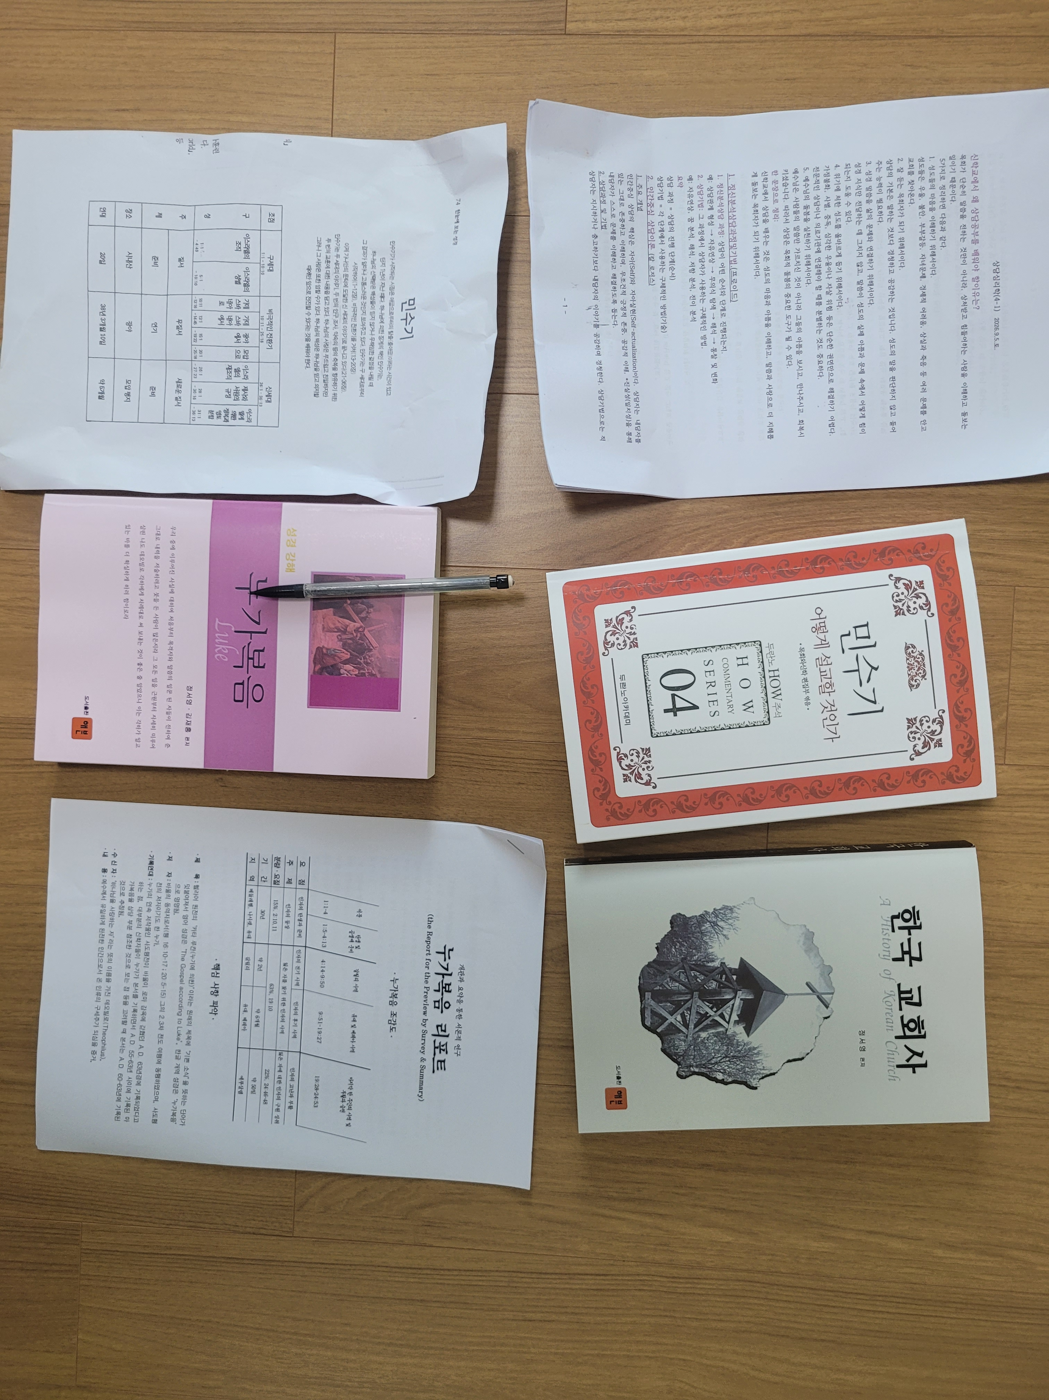
Figure 1: Required books by Korean Seminary.
These books, I am supposed to read, but because I am not good at Korean, it is very difficult to understand everything. Thus, the seminary is very understanding of me. But I am making an effort to do my best, and write a report for the red-colored book. There are many more books, but I am reading what I can at the time.

Church Materials
Figure 2: Church materials for sermons and Bible study.
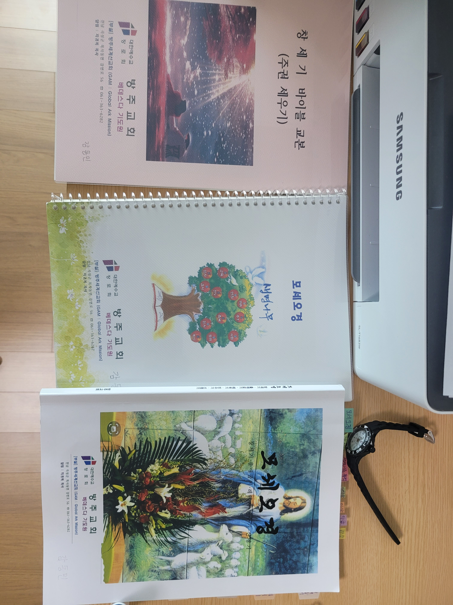
These materials are for church sermons and for Bible studies. They have Bible verses on every page and have questions about what the Bible verses mean. We discuss these questions and the contents of these books at our homes for Bible studies. We pray and sing praise songs through the Bible worship songs that are in the back of our Korean Bibles. These worship songs are old songs that are commonly American hymns.

Ginseng (CK Product)
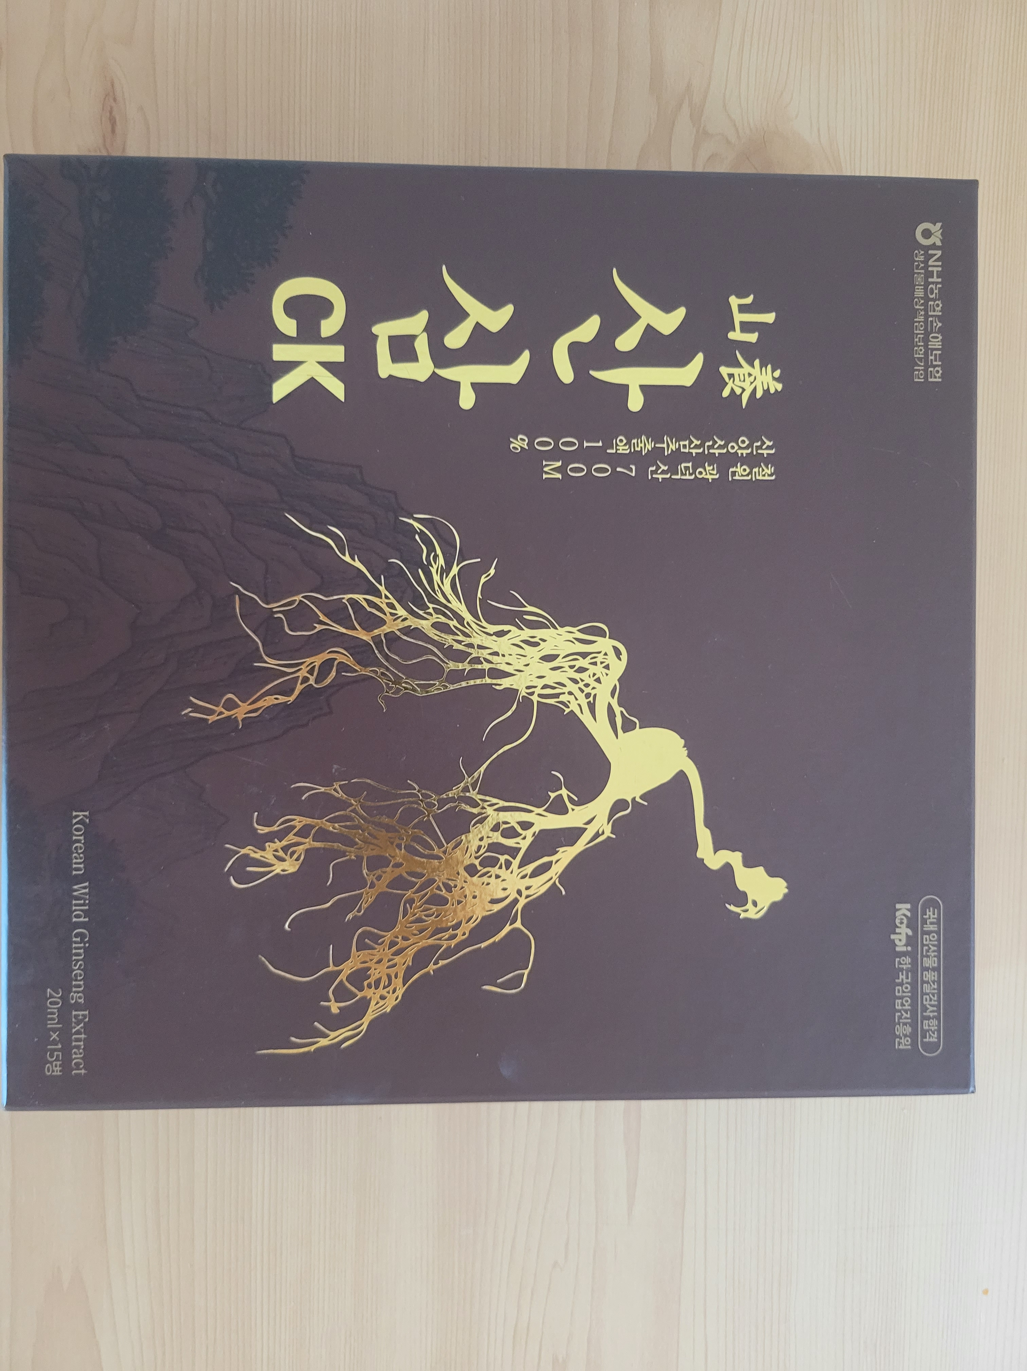
Figure 3: Gingseng (CK product) that my dad gave to me, and thus, to the churches.
My dad is creating a company that may be called CK. He’s been working on a certain chemical that comes from Ginseng, I believe, which is a herbal medicine of Ancient Korea. It has very good nutrition and is very expensive. It is known throughout the world, especially Asia. He did research on it, as he is a chemist, who worked at the big billion-dollar company Amgen.
He gave all the Ginseng boxes to our church so that they can distribute it to many people who are Christian and want to experience the blessing and love of Christ. It is a discussion of whether this is good for the church – “Is only hymns good for God,” one may ask. But I think this is good and that we need companies that serve Christ. I think my dad serving the church with his capabilities is a beautiful thing.

Testing
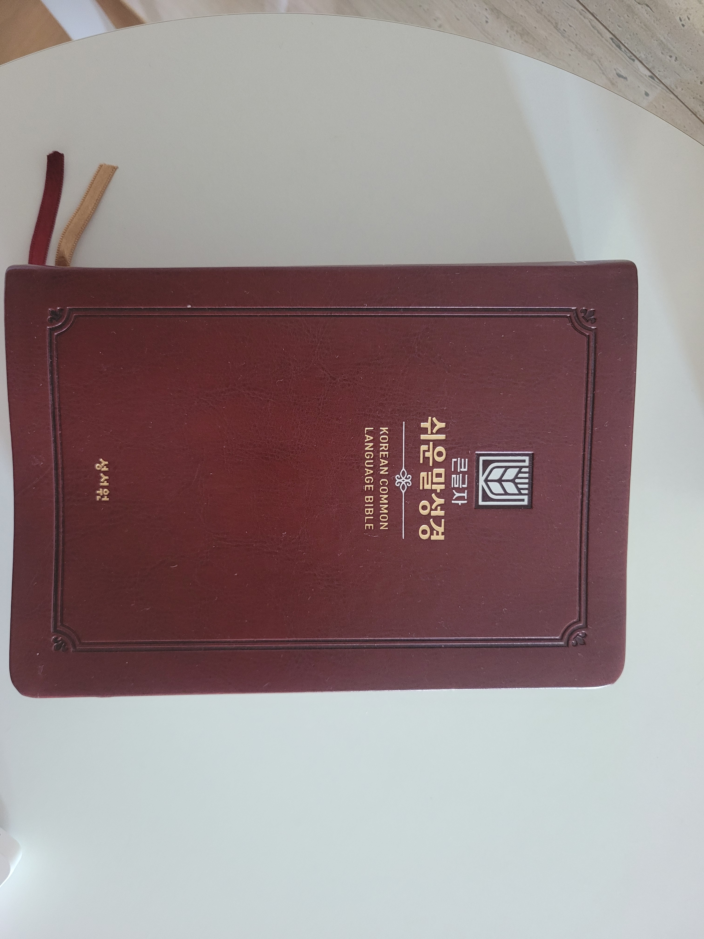
Figure 4: My Korean Bible that is in simplified Korean that I read (I try to read daily) to learn Korean and to edify my soul.
Korean is an easy language, but when it is used for advertisements, I’d say any Christian and normal person would say, “I don’t want to learn Korean through watching advertisement-language.” Thus, I read the Bible to learn Korean. Korean is a tool and a medium, it can be used for good or for evil, and the Bible is a beautiful entity that when spoken through many languages, can produce a blessing for people. Advertisements are very good, but ultimately, they are so transient – everyone knows this. But the Bible has lived for centuries. When I read this Bible to edify my soul and to serve others, I feel blessed.
The Korean language is a tool that can be used to reach other people through evangelism, and that is one reason why I am learning Korean – to serve the people of God and to reach the lost and unreached.

Picture
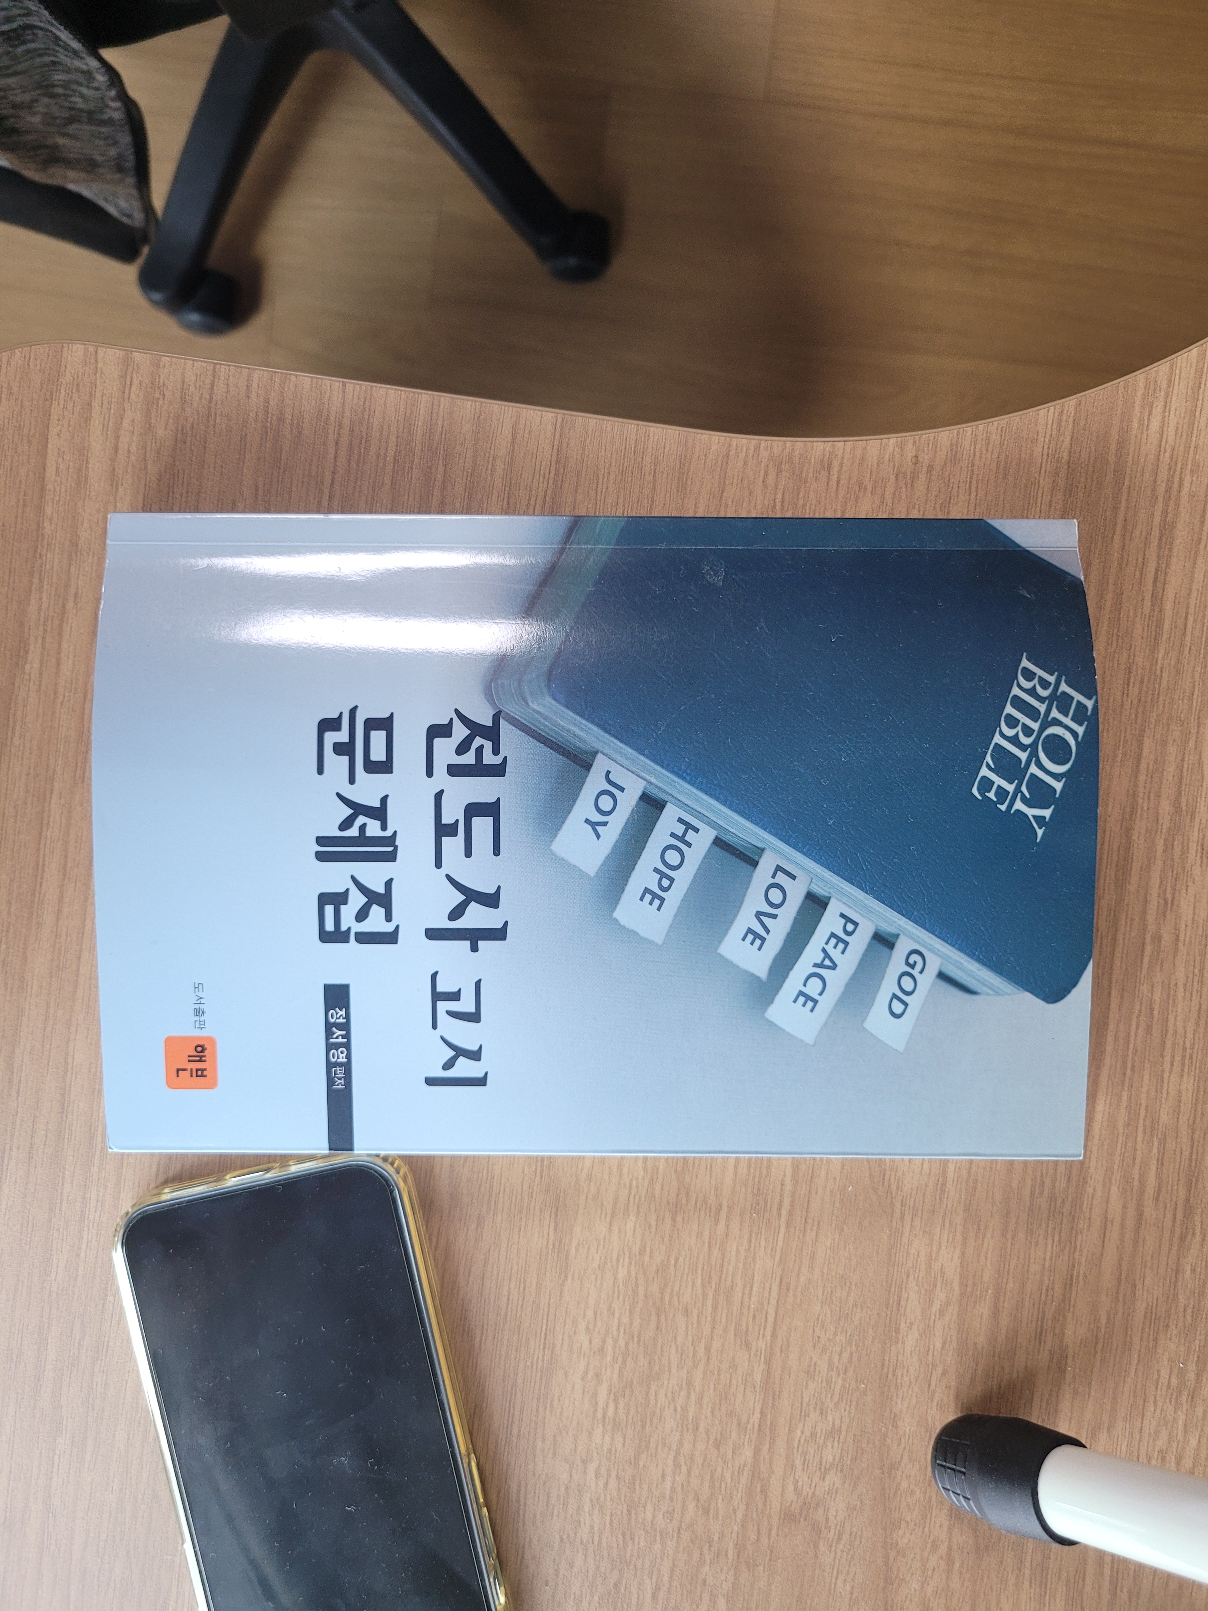
Figure 5: My Evangelist textbook.
In Korea, before you become a pastor, you must first become an Evangelist. It is a training period before you can become a pastor. And I am in that stage right now as I am completing my Mdiv. This book, in the picture above, is a book full of questions of almost every chapter in the Bible. They ask specific questions of comprehension of nuance detail. For me, this serves as a way to measure my Korean comprehension and ability to navigate the Korean bible – physically. When flipping through pages of Scripture, it is always better to use a physical Bible – it is still hard to use electronics for the Bible, especially Korean, surprisingly.
At the conclusion of the ten weeks, the student will prepare a two (2) page “Practicum Project Summary,” summarizing the full project and describing the benefits of the ministry engaged throughout the quarter. Mention should be made of any insights gained and learning experiences that occurred during ministry exercises. This should include changes that would make the experience more beneficial to you or others – what improvements
would you recommend? As applicable, documentation should be made of any complementary materials used to augment the practicum, such as handouts, visual aids, study guides, reading lists, and academic materials.

Summary
The full project was a success. As I lived my life and served in the ministry, I learned that I was doing valuable work, even when I didn’t realize it. There are so many details in our lives that are used for ministry, but we don’t record it all. To truly record all the details of my life used for ministry, it would require too much information.
But when I recorded what I remembered, I felt so proud and so elated that I was doing valuable work. I know I’m not doing the best work or even my best effort, but I’m doing what I can given the situation that I’m in. And I see that I have done very good things for the Lord and that I am pleased with my performance.
I have prayed, done computer work for the church, gone to revivals, attended services, fixed computers and cameras for the church, counseled church members, fellowshipped with them, prayed with them, struggled with them, and given my service and performance (through dance and singing) and through evangelism.
The benefit is that I realize that I am living for Christ in even the smallest ways. And that Christ is in me and that I have a lot of potential as a real, and good pastor one day. A pastor is not one who serves the church on Sunday only, but a pastor is one who serves the world at all times. A pastor shepherds the flock, but he realizes that there are people who need to know Christ who are outside the flock. He organizes the church, and establishes the framework to send out missionaries. He is the head of the church on earth, and he has lots of authority and responsibility.
And that is what I realize I want to be, and that is my destiny. The benefit of this assignment is that I am coming out knowing my future and destiny as a pastor. All my life is geared toward ministry and Christ, and I want to serve him and know him more. The hours recorded in this weekly log show that my life is ready to graduate and serve God. I even have had a chance to counsel a fellow church member, but I don’t know if I was effective. But I realize more than looking at others, that looking at my hours and my life that I am geared toward serving God as a pastor and evangelist.
I want to thank Faith Seminary for this assignment, and ask for prayer for my future. I hope to be a pastor who does many things for Christ, and I don’t want to be put in a box, but rather flourish with all my talents and colors. And I thank everyone for their support, and I’m thinking of attending graduation in Washington, but that is a little far, but I know that there are good options.
Thank you,
Dennis

